ASSIGNMENT : 4

1.
Create a comparison table showing which security responsibilities belong to the cloud provider and which belong to the user for a food delivery app like Zomato running on AWS, Azure, or Google Cloud.
ANS :
Security Responsibilities for a Food Delivery App Like Zomato on AWS, Azure, or Google Cloud
Cloud security follows a shared responsibility model: the cloud provider secures the underlying cloud infrastructure, while the customer is responsible for securing their applications, data, identities, and configurations.
Security Area | Cloud Provider  Responsibility | User / Zomato Responsibility
Physical Security | Protect data centers, servers, buildings, and physical network equipment. | No responsibility for physical data-center security.
Cloud Infrastructure | Secure the underlying hardware, networking, storage, and virtualization infrastructure. | Properly configure and use the cloud services securely.
Operating System | Responsible for the host infrastructure and managed services where applicable. | Patch and secure the OS of self-managed EC2/VM instances.
Application Security | Provide secure cloud services and security features. | Secure the Zomato application, APIs, code, libraries, and dependencies.
Customer Data | Protect the cloud infrastructure where data is stored. | Encrypt and properly manage customer information, restaurant data, orders, addresses, etc.
User Accounts & IAM | Provide IAM/security tools. | Create users, roles, permissions, MFA, and follow least-privilege access.
Network Security | Secure the underlying cloud network infrastructure. | Configure VPC/VNet, subnets, firewalls/security groups, routing, and network access rules.
Database Security | Secure the managed database infrastructure where applicable. | Configure database permissions, encryption, backups, and access controls.
Encryption | Provide encryption technologies and key-management services. | Enable encryption and properly manage encryption keys and access to them.
DDoS Protection | Provide infrastructure-level DDoS protection and security services. | Configure appropriate DDoS protection services and secure the application against attacks.
Logging & Monitoring | Provide monitoring and logging tools. | Enable logs, monitor suspicious activity, configure alerts, and investigate incidents.
Backup & Recovery | Provide reliable cloud infrastructure and backup/recovery features depending on the service. | Configure backups, retention policies, disaster recovery, and regularly test recovery.
Security Updates | Patch the provider-managed infrastructure. | Apply security patches to customer-managed servers, applications, and dependencies.
Compliance | Maintain compliance certifications for the cloud infrastructure. | Ensure the Zomato application and handling of customer data meet applicable legal and regulatory requirements.

2.
Sign up for a free trial on AWS, Azure, or Google Cloud, and create a new user account with limited permissions (for example, only allow access to storage buckets or databases, but not to billing or admin asettings).
ANS :
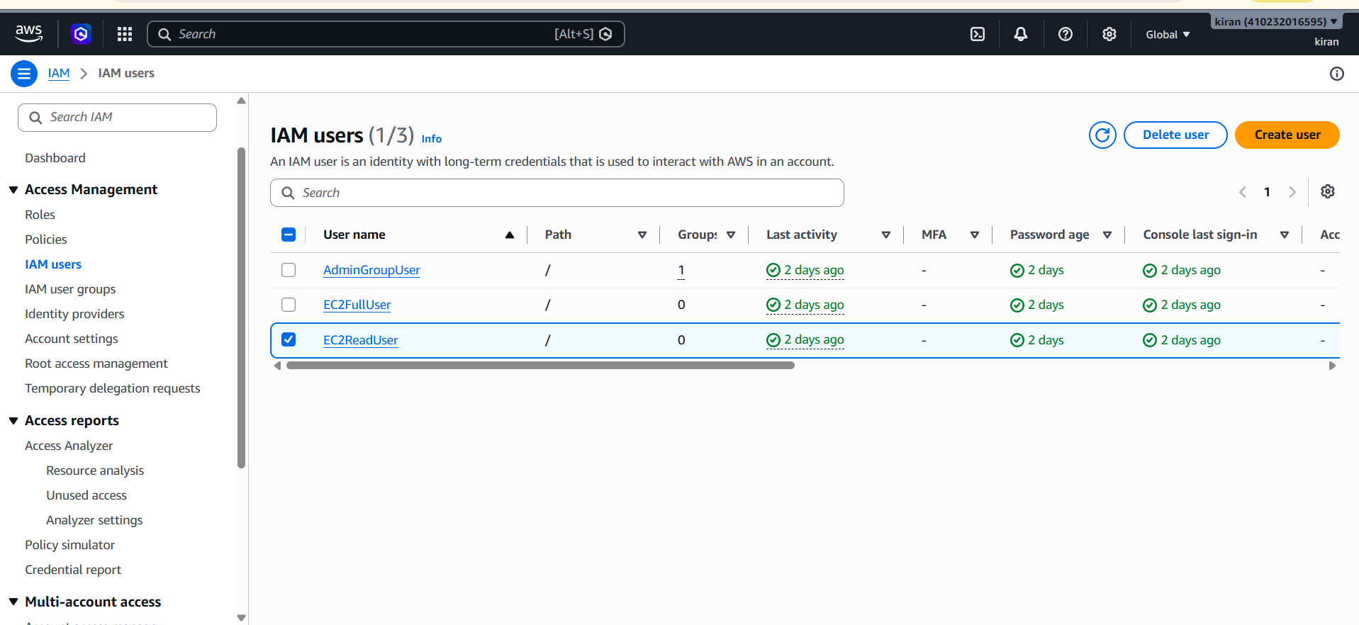
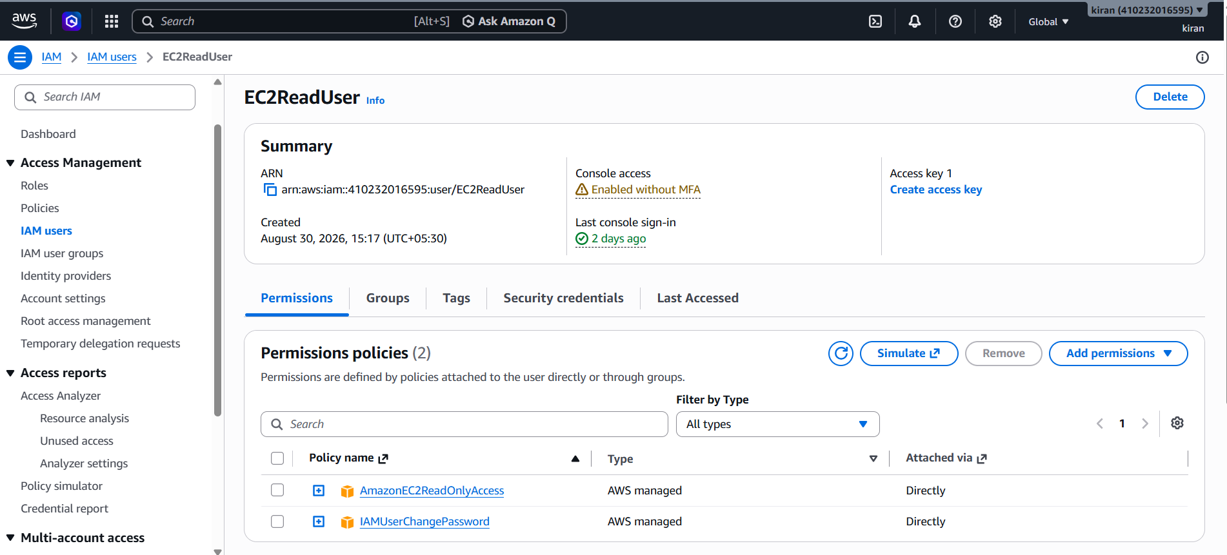
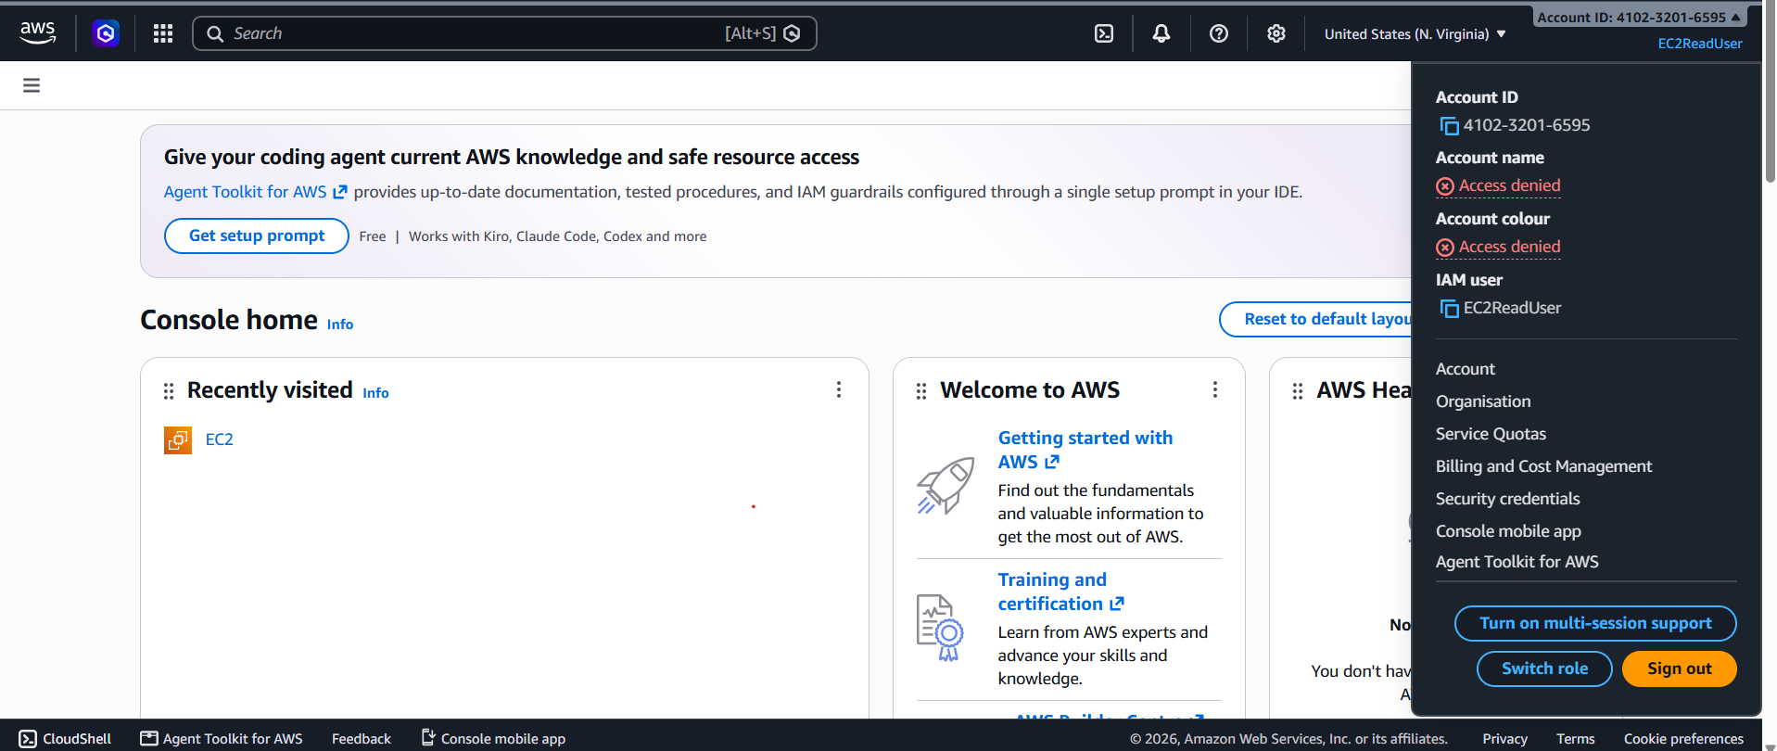
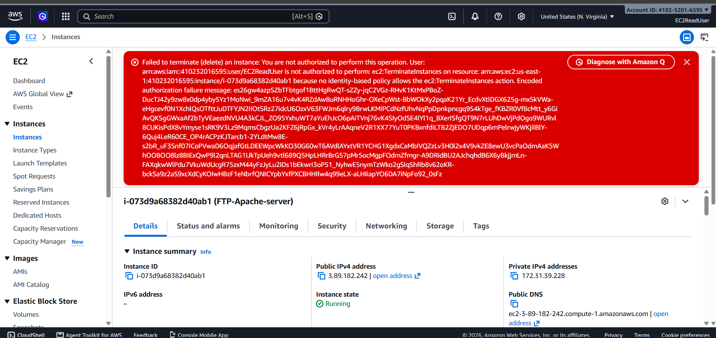

3.
Configure a custom policy in your chosen cloud platform that allows a user to upload images to a storage bucket but denies them permission to delete any files.<br><br><em><strong>Hint:</strong> Look for storage service permissions such as 'PutObject' and 'DeleteObject' in the policy editor.</em>
ANS :
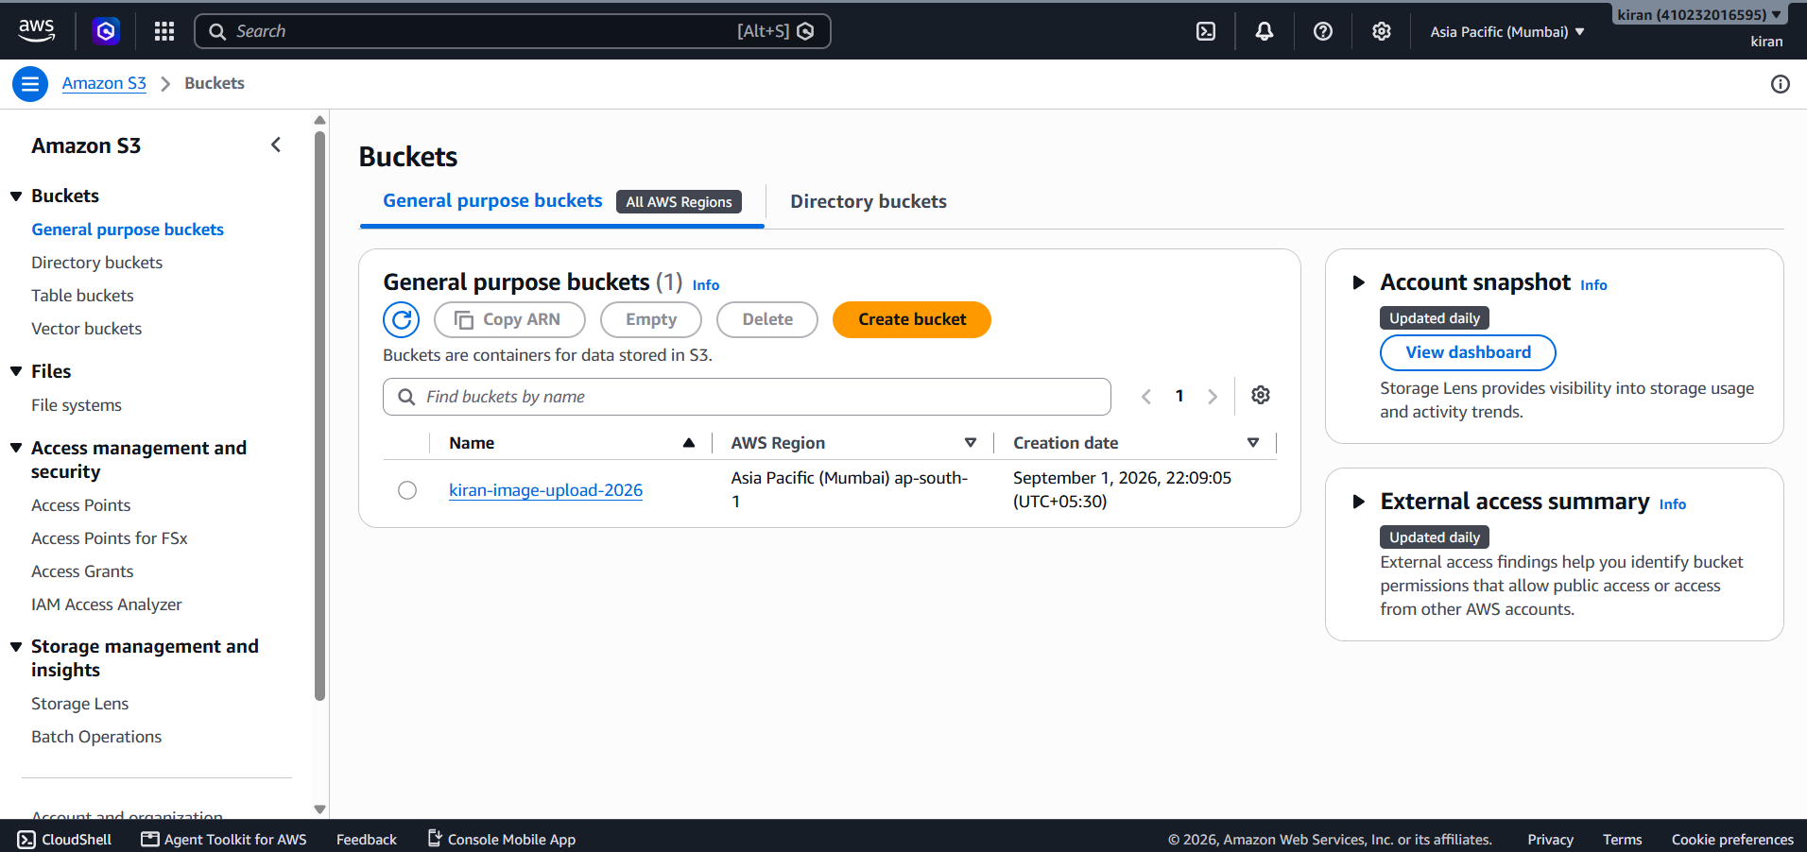
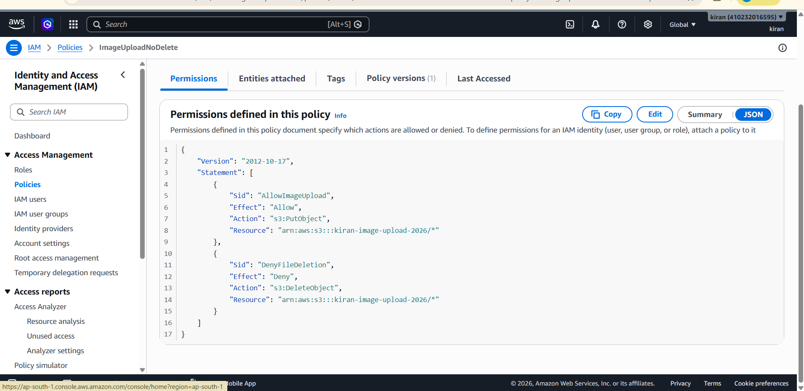
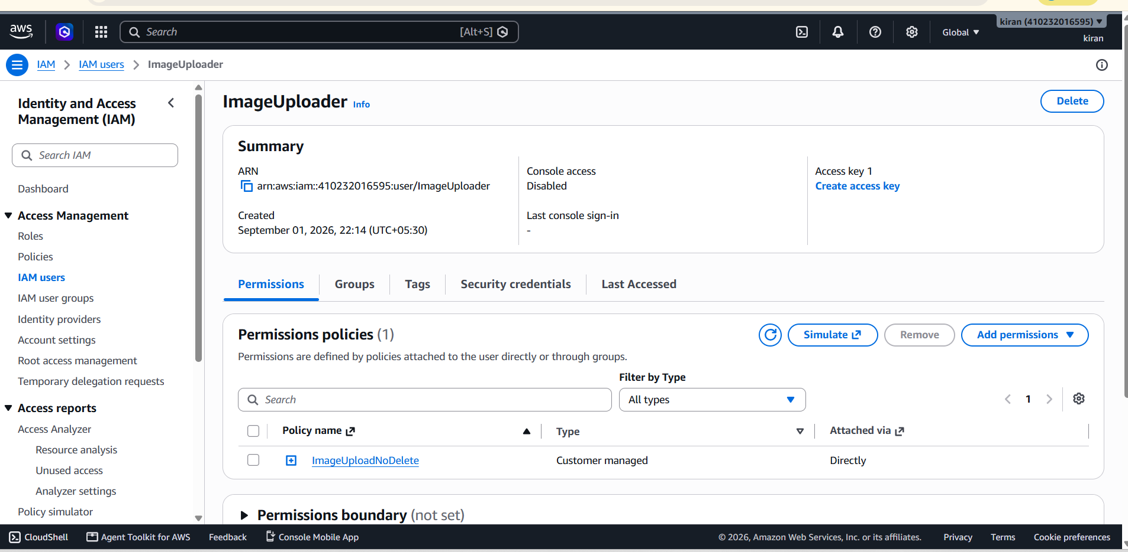
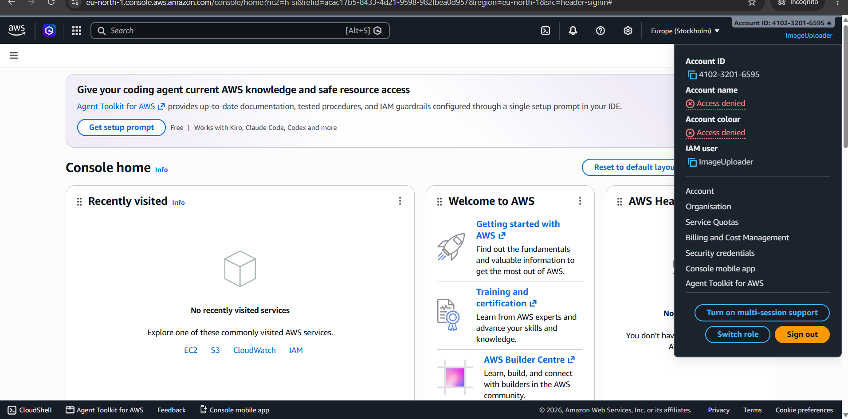
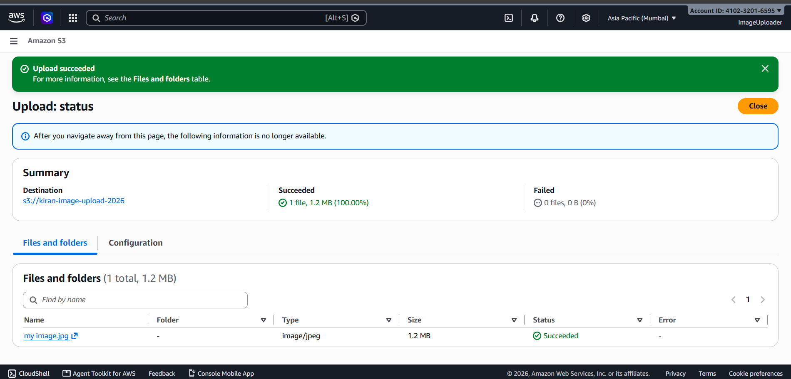
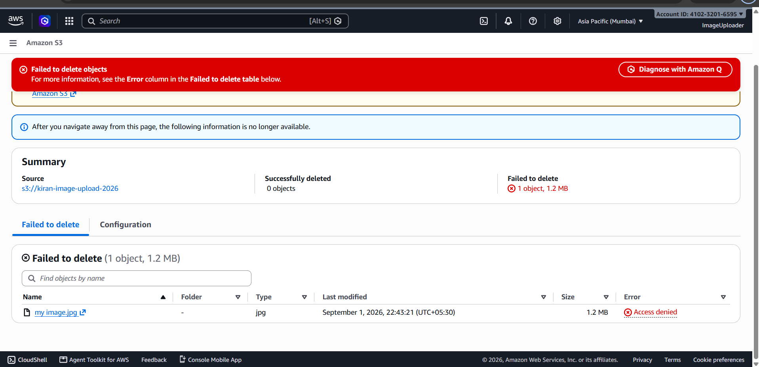

4.
Simulate a real-world scenario: Imagine you are part of a team managing a cricket ticket booking app (like BookMyShow). Assign the following roles using your cloud provider's IAM or equivalent: one user can only view booking data, another can edit booking data, and a third can manage user accounts.<br><br><em><strong>Hint:</strong> Use built-in roles or create custom ones if needed.</em>
ANS :
AWS IAM (Identity and Access Management) is used to securely control access to AWS resources. IAM allows administrators to create users and assign permissions according to their responsibilities. In this scenario, different permissions are assigned to employees of a cricket ticket booking application based on their roles.
Roles Assigned
User | Permission | Purpose
BookingViewer | AmazonS3ReadOnlyAccess | Can only view booking data
BookingEditor | AmazonS3FullAccess | Can view and modify booking data
UserManager | IAMFullAccess | Can manage user accounts and IAM permissions

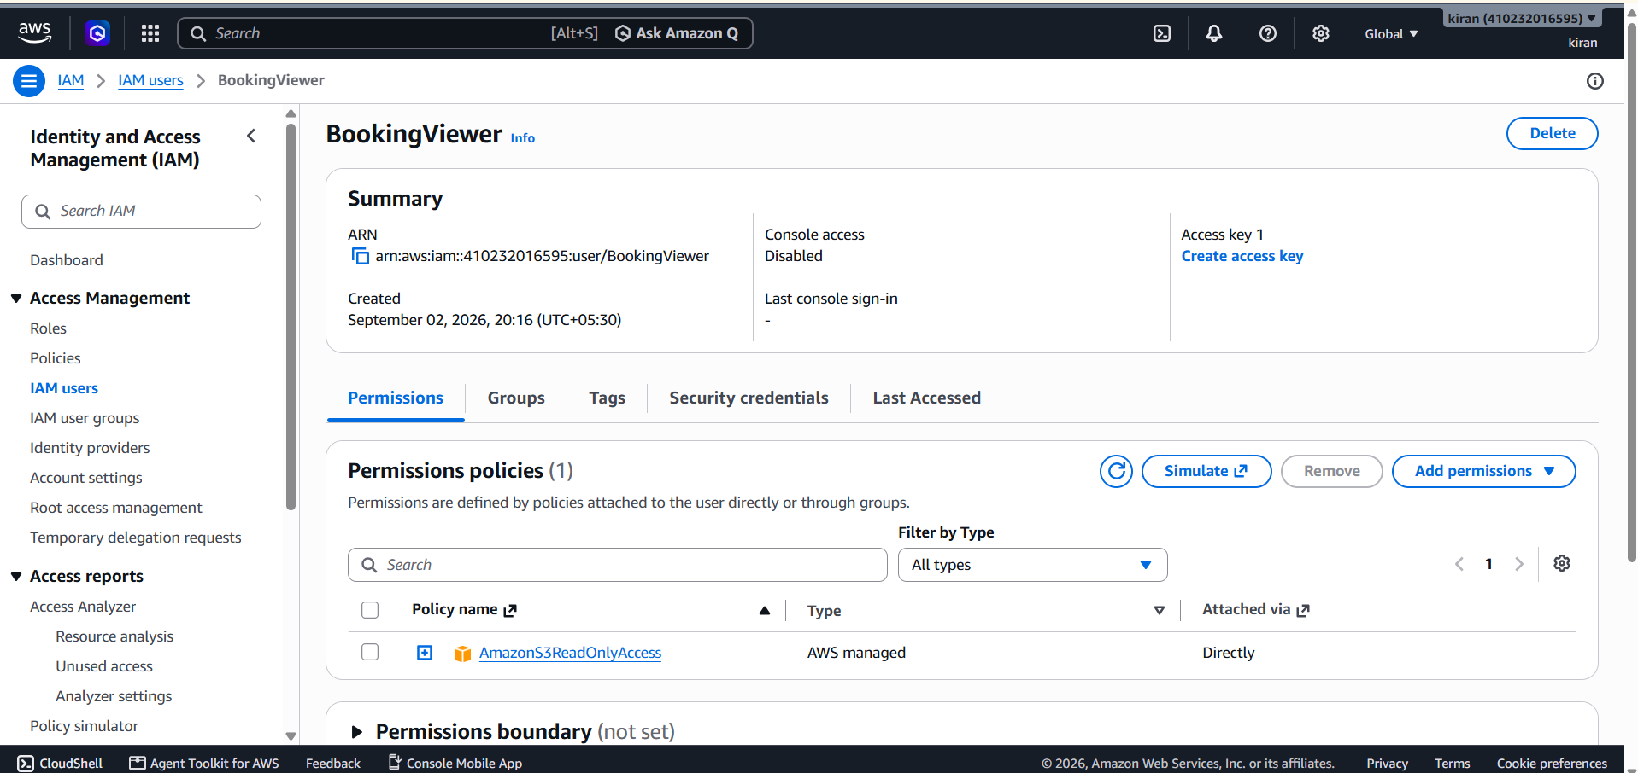
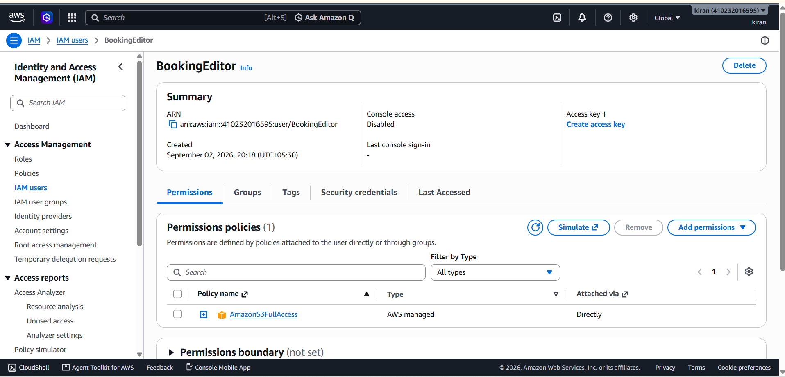
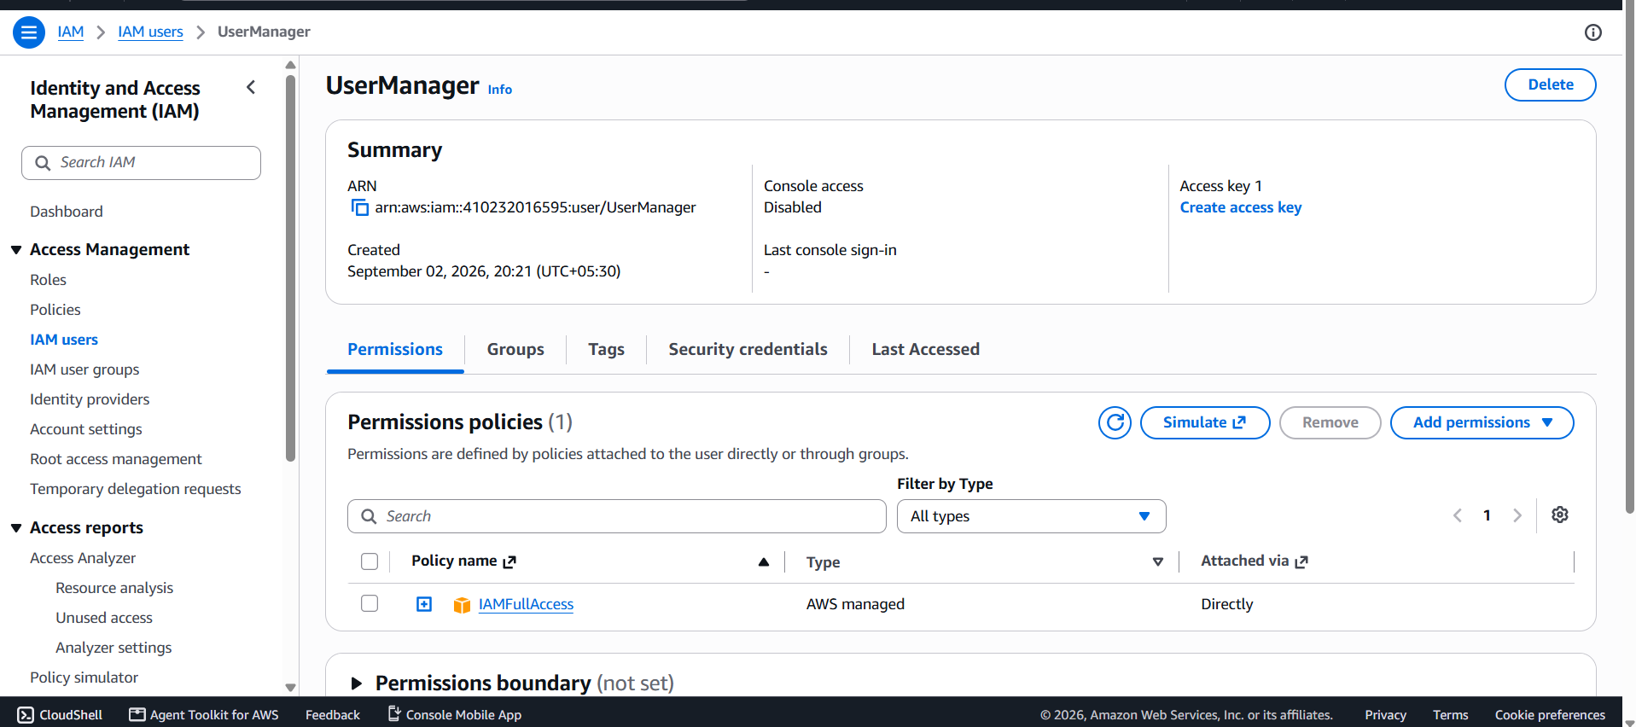
Result:
The three IAM users were successfully created with different levels of access according to their responsibilities in the cricket ticket booking application.
5.
Find and describe one real security incident from the last 3 years where a cloud misconfiguration (wrong permissions or policies) exposed user data. Explain in 3-4 lines how applying the Shared Responsibility Model could have prevented it.
ANS :
Real Security Incident: Microsoft Power Apps Data Exposure (2022)
In 2022, security researchers discovered that misconfigured Microsoft Power Apps portals had exposed sensitive data from hundreds of organizations. The exposed information included personal details, vaccination records, and other sensitive user data. The main problem was that some organizations had incorrectly configured permissions, allowing data to be accessed publicly.
How the Shared Responsibility Model Could Have Prevented It
Under the Shared Responsibility Model, Microsoft is responsible for securing the cloud infrastructure, while the organization is responsible for securely configuring its own applications and data. Organizations should have checked access permissions and ensured sensitive data was not publicly accessible. Regular permission audits and least-privilege access could have prevented unauthorized users from viewing the exposed information.

